
NAME: BISMA FATIMA
CLASS: CS A
ROLL NO: F24605036
COURSE: INFORMATION SECURITY
COURSE CODE: CS-291
LECTURER: MISS ATTIA ASHRAF

LAB 09

Getting Started with NMAP
Open the Terminal and type:
nmap
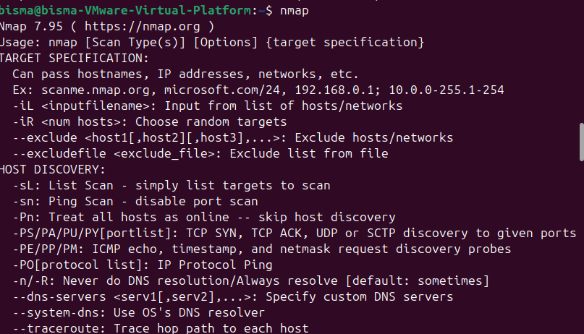
Find Live Machines
Introduction: Ping Sweep/Scan (-sP) is used to find live machines from a range of IP addresses. It sends ICMP echo request to multiple machines. In case of ping request, a single packet (56 bytes data + 08 byte header) is sent. It also determines round trip time.
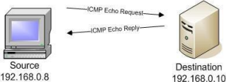
Command:
nmap –sP <target>
For example:
nmap -sP 142.250.201.142
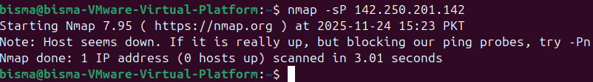
Discover Open Ports
Introduction: In computer networking, a port is a communication endpoint. For example, Server Message Block (SMB) is a network file sharing protocol used by Windows machine for file and printer sharing. It operates on TCP port number 138 and 445.
Attackers can exploit the vulnerabilities associated with SMB protocol if these ports are open. Microsoft released a patch for SMB v1 vulnerability but most of the users installed pirated version of operating system which will never be updated.
Command:
nmap –p <port> -v <target>
(-v is the verbose output to display extended information)
For example:
nmap -p 1-65535 -v 142.250.201.142
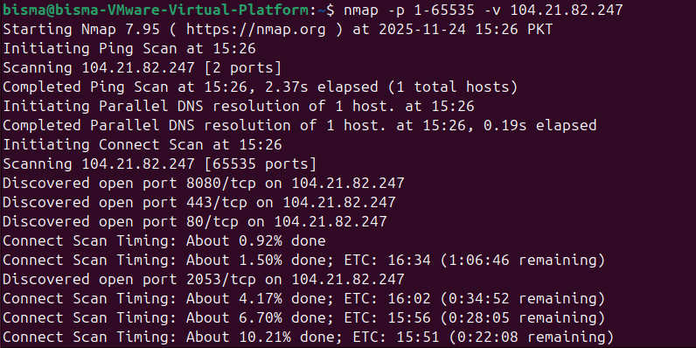

a) TCP Connect Scan [-sT]
Introduction: TCP Connect scan detects open ports by three-way handshake. It is also referred as FULL OPEN Scan.
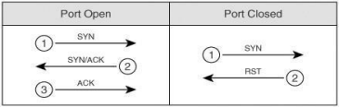
Command:
nmap -sT <target>
For example:
nmap -sT 172.16.4.51
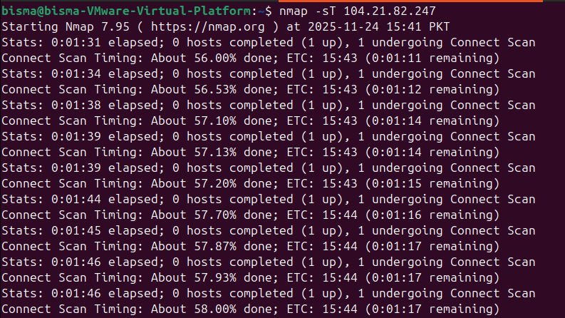

b) SYN Stealth Scan [-sS]
Introduction: It is based upon TCP handshake. It is also referred as HALF OPEN Scan. In this type of scan, Nmap sends SYN packet:
∙ If port is open - it responds with ACK.
∙ If port is closed - it responds with RST.
∙ If port is filtered - it simply drops SYN packet.
Command:
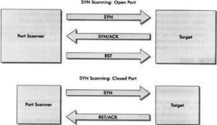

nmap –sS –A –O <target> –p <port>
(Where –A is Aggressive scan, -O is operating system)
For example:
nmap -sS -A -O 142.250.201.142 -p 445
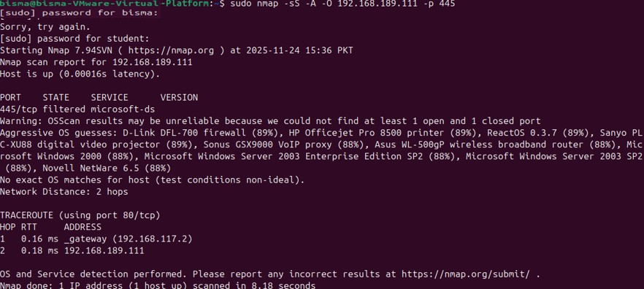

c) UDP Scan [-sU]
Introduction: This type of scan is used to scan UDP ports. Nmap sends the 0-byte UDP packets. If source receives an ICMP Port Unreachable message, then the Port is closed.
Command:
nmap –sU <target>
For example:
nmap -sU 142.250.201.142
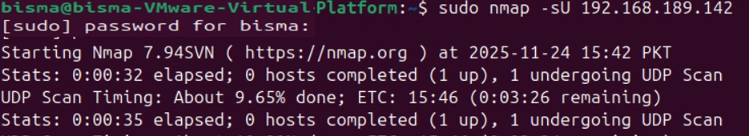

Post-Lab Tasks
1. Write a brief summary of each scan type you performed. Include the benefits and drawbacks of each method. Why might one use SYN Stealth Scan over a TCP Connect Scan, or vice versa?
ANSWER:
Scan Type | Description | Benefits | Drawbacks
TCP Connect Scan (-sT) | Completes full TCP handshake to check port status | Reliable and accurate; works without root privileges | Easily detectable by firewalls and IDS
SYN Stealth Scan (-sS) | Sends SYN packet and analyzes response without completing handshake | Faster and stealthier; avoids logging in some systems | Requires root/admin privileges; may be blocked by firewalls
Idle Scan (-sI) | Uses a third-party “zombie” host to send spoofed packets | Highly stealthy; hides source of scan | Complex setup; depends on vulnerable idle hosts

Why choose SYN over TCP Connect?
- Use SYN Stealth Scan when stealth is critical, such as during penetration testing or when avoiding detection by intrusion detection systems.
- Use TCP Connect Scan when accuracy is more important than stealth, or when you lack root privileges.

2. Describe how a network administrator might use these scan techniques to secure a network. How could an attacker use Nmap scanning to identify vulnerable services, and what defenses could mitigate these scans?
ANSWER:
How network administrators use Nmap:
- Audit open ports to ensure only necessary services are exposed.
- Detect unauthorized services running on hosts.
- Verify firewall rules and test segmentation.
- Monitor changes in network topology or host availability.
How attackers use Nmap:
- Identify open ports and services to find entry points.
- Detect OS and version info to exploit known vulnerabilities.
- Map network structure to plan lateral movement.
Defensive measures:
- Firewalls to block unsolicited traffic.
- Intrusion Detection/Prevention Systems (IDS/IPS) to alert or block scans.
- Rate limiting and port knocking to obscure service availability.
- Honeypots to detect and mislead attackers.

3. Explore the concept of “stealth scanning” further. Research additional techniques (e.g., Idle Scans) that can make Nmap scanning less detectable.
ANSWER:
Stealth scanning aims to avoid detection while gathering information. Beyond SYN scans, here are more advanced methods:
- Idle Scan: Uses a third-party host to send spoofed packets, making the scan source invisible.
- FIN, Xmas, and Null Scans: Send unusual TCP flags to probe firewalls and detect open ports without triggering standard alerts.
- Fragmentation Scans: Break packets into fragments to bypass deep packet inspection.
- Decoy Scans: Include multiple spoofed IPs to confuse defenders about the real source.
These techniques are useful for attackers trying to evade detection, but they can also be used by ethical hackers to test the robustness of network defenses.

